W10 — Coarse Product Loss in a Confined Tunnel
W10 is significant because substantial coarse and mixed-product accumulation is present outside the intended carrying path of the conveyor within a restricted tunnel environment. The photographs clearly show the resulting accumulation and the limited access available around the conveyor, although the present evidence does not establish one single initiating cause for every deposit. The response should therefore begin by understanding the conditions that are allowing product to move toward or beyond the belt edge, rather than assuming that the surrounding accumulation is caused by one isolated defect.

Relevant contributors such as loading position and distribution, feed condition, belt tracking and the local belt, trough and support geometry should first be checked and corrected where a contributing condition is confirmed. Where a tendency for lateral product escape remains after those primary conditions have been addressed, flexible belt-compatible side skirting or spill sealing can then be used to help keep the transported product within the usable carrying area of the belt.

The proposed skirting is intended to act directly at the conveyor carrying edge, along the conveyor sides and inside the carrying width, so that laterally moving product is retained on the belt before it can escape into the surrounding tunnel area. The skirt or seal should form a near-vertical containment surface along the troughed belt edge, with the lower sealing relationship selected so that normal belt movement and tracking can be accommodated without damaging rubbing, rigid belt guidance, excessive product trapping or inaccessible build-up.

Conceptual skirting arrangement

The proposed W10 containment philosophy is illustrated by two complementary drawings.

CTD-010 / DRAW-0010 — W10 Side-Skirting / Product-Containment Concept

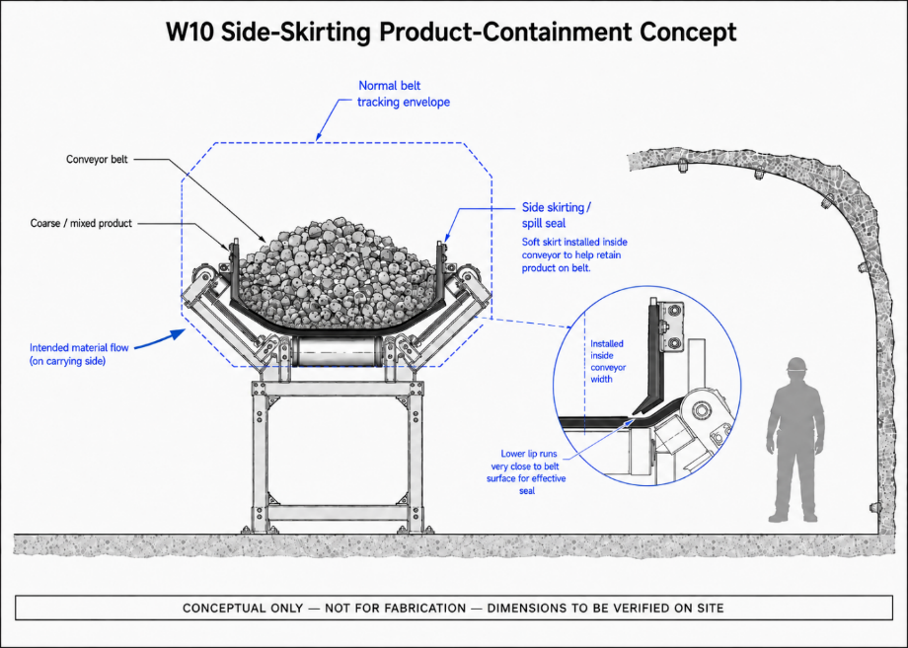
This drawing places the proposed skirting into the W10 tunnel context. Its purpose is to show where the skirting is intended to act relative to the conveyor, carried product and restricted surrounding access. The important point is that the containment element sits at the conveyor carrying edge and acts before product has escaped into the surrounding tunnel.

CTD-011 / DRAW-0011 — Conveyor Side Skirting / Spill Seal Concept — Cross-Section

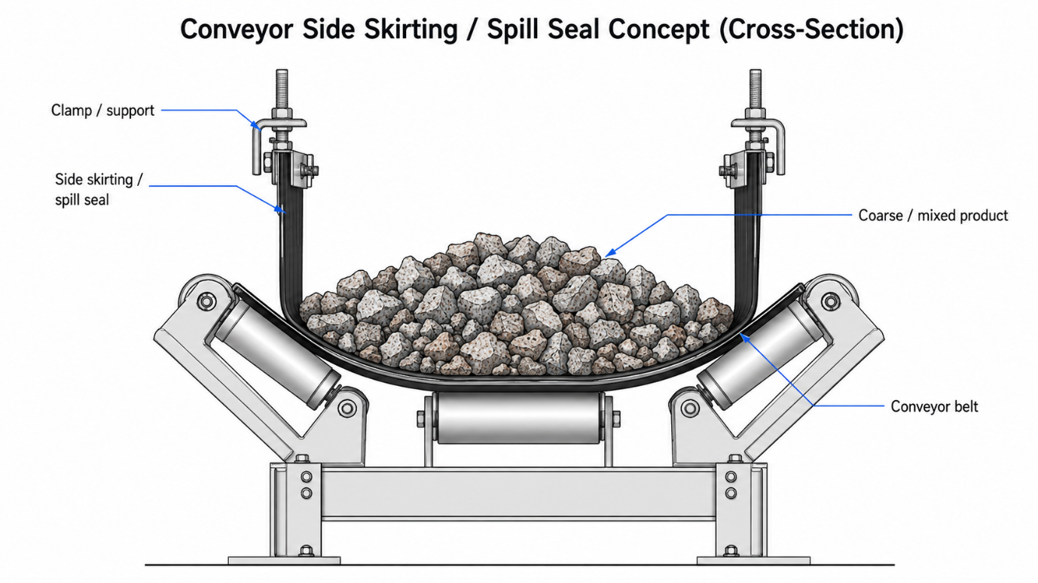
This drawing explains how the skirting principle works in cross-section. A flexible skirt or spill-seal element is supported along the conveyor side and extends downward on the inside of the carrying width, close to or in controlled belt-compatible contact with the troughed belt surface as determined by the selected system. In this way, the skirt provides a longitudinal containment boundary that helps retain coarse and mixed product on the belt.

The two drawings should therefore be read together: DRAW-0010 shows where the skirting is used in the W10 conveyor/tunnel arrangement, while DRAW-0011 explains the physical side-skirt/spill-seal mechanism. Neither drawing defines the final OEM product, skirt material, dimensions, contact pressure, clamp arrangement or installation geometry. Those details remain subject to verified site geometry and OEM/responsible detailed design. This is also the controlling interpretation in the current conceptual-figure register.

Wider applicability of the principle

W10 provides a useful location for proving this containment principle because the consequence of lateral product loss is particularly significant where access around the conveyor is restricted. If the skirting arrangement proves effective at W10 under representative operating conditions, the same functional principle may be considered at other conveyor sections where limited operating space makes recurring product accumulation difficult to access, recover or manage.

This could include appropriate restricted-access or spatially constrained sections of the underground conveyor route, provided that the local loss mechanism and conveyor geometry first confirm that side skirting is a suitable control. The intention is not to reproduce the W10 installation unchanged at every such location, but to apply the proven principle where a genuine residual lateral-containment requirement exists.

The same side-skirt/spill-seal principle also carries forward into the Sample Conveyor assessment. At Sample Conveyors 2 and 3, however, it remains a secondary or residual control: feed quantity and variation, product-size distribution, loading position, usable carrying geometry and belt tracking should first be understood and corrected where necessary at those locations. Only once those primary contributors have been addressed should the remaining skirting requirement be defined.
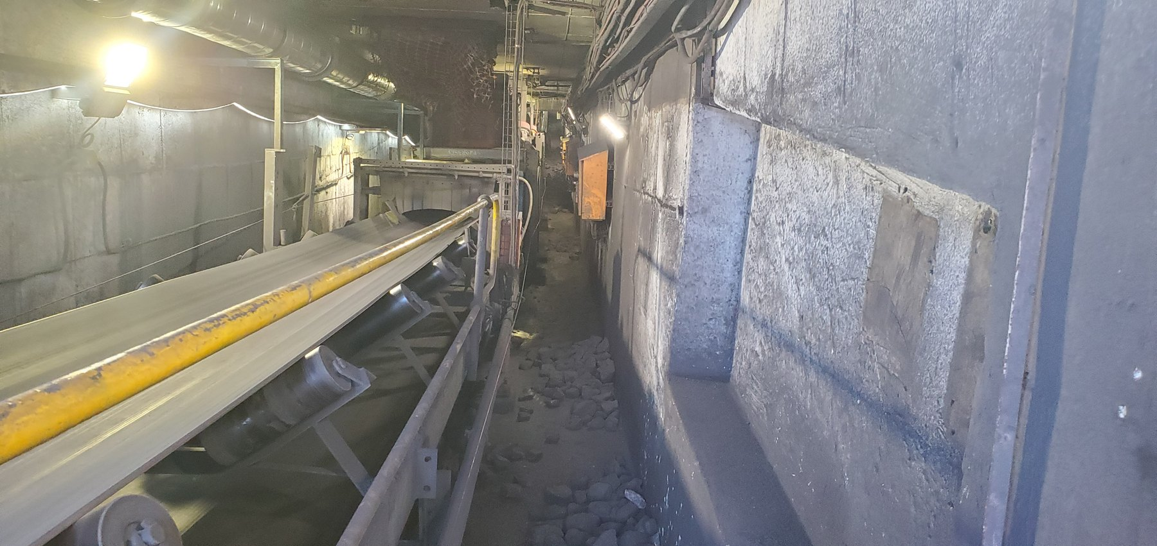  W10-REF-010 — long tunnel view establishing the confined topology and restricted access. |  | 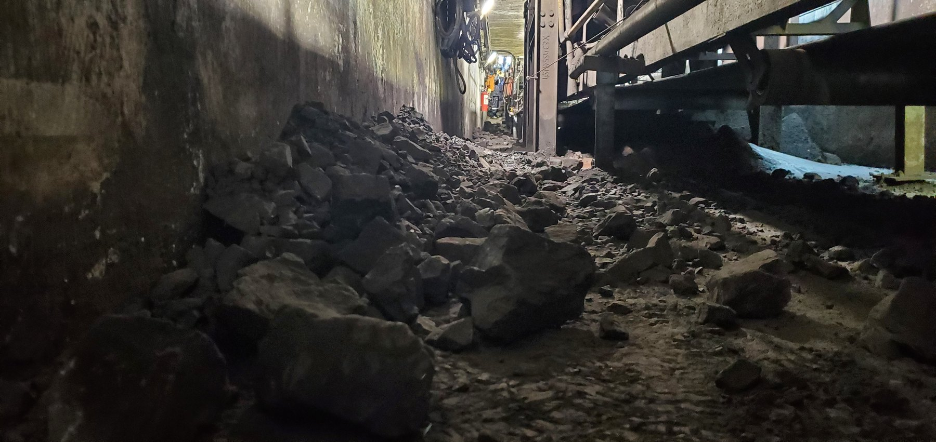  W10-REF-002 — principal coarse/mixed-product consequence in the access route.
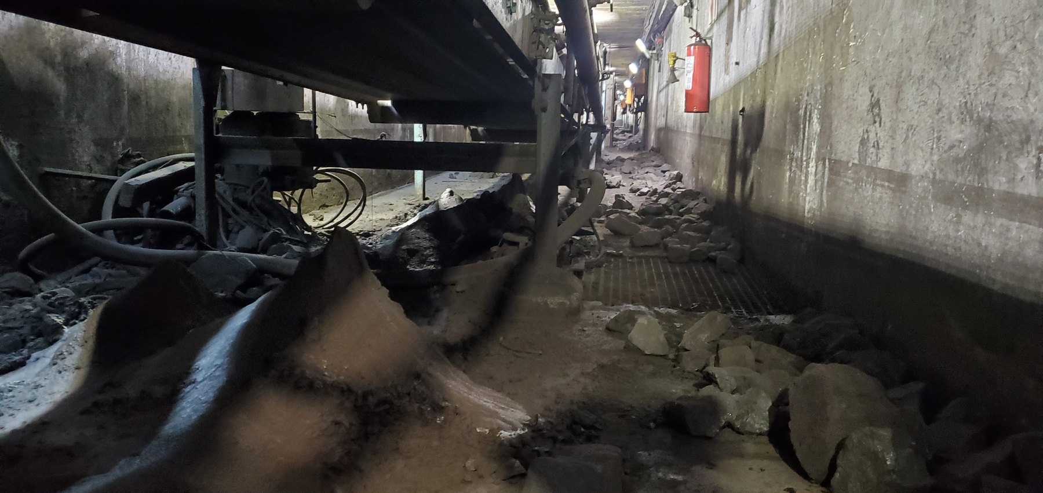  W10-REF-006 — product distributed below the conveyor around components, explaining local geometry. |  | 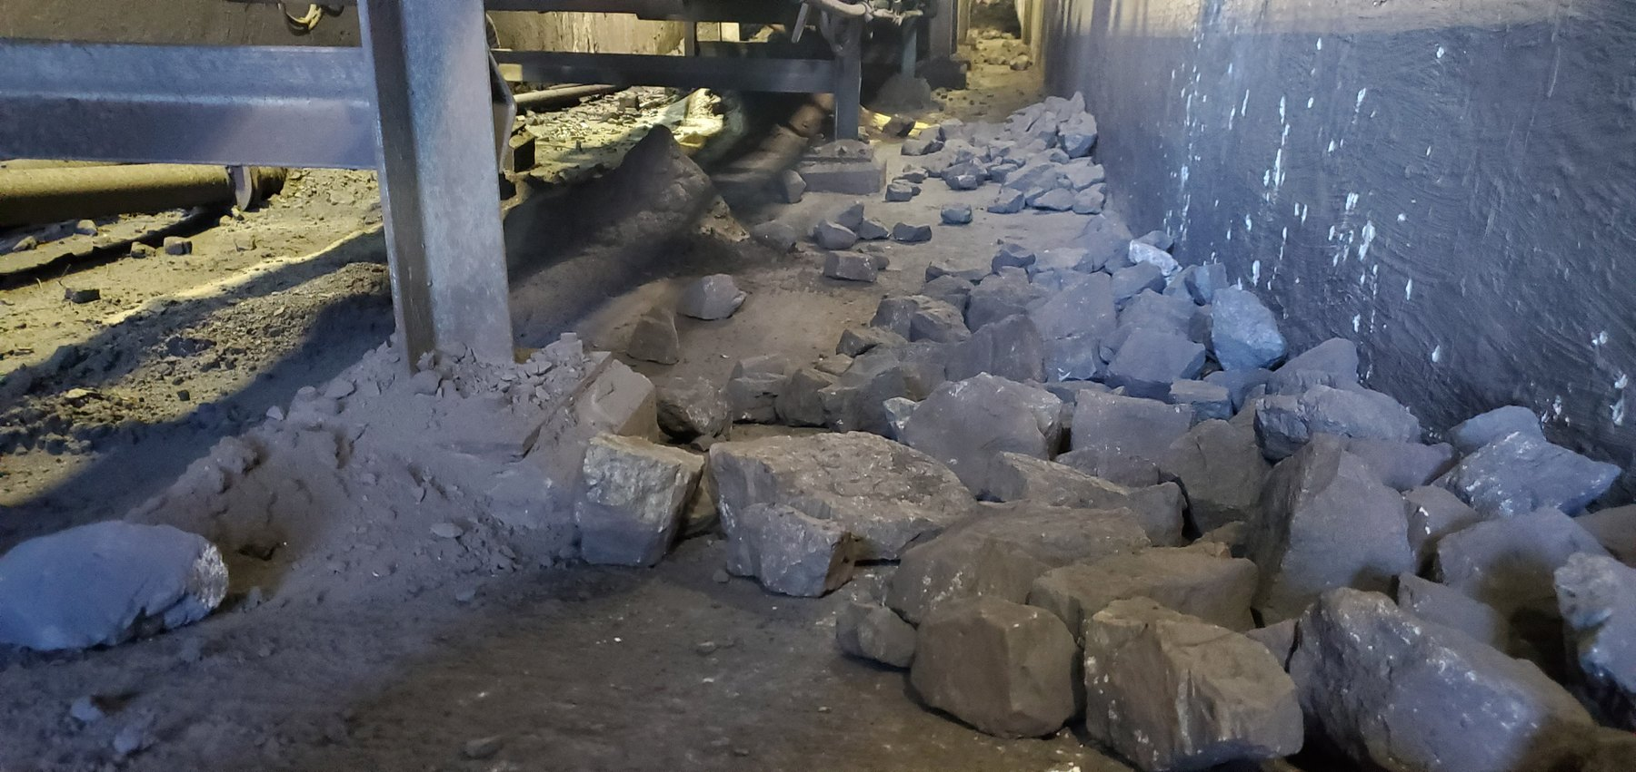  W10-REF-009 — product immediately beside support steel; useful context for local side-containment feasibility.
OBSERVATION | Coarse and mixed product has moved outside the intended carrying path and accumulated within the restricted W10 tunnel area. The photographs demonstrate both the scale of the accumulated consequence and the limited access available around the conveyor.
ENGINEERING ASSESSMENT | Where lateral product escape remains after confirmed primary contributors have been addressed, belt-compatible side skirting or spill sealing positioned within the carrying width provides an appropriate residual-containment principle by acting directly at the carrying edge to help retain laterally moving product on the belt.
RECOMMENDED NEXT ACTION | Verify representative loading and belt tracking together with the local belt, trough and support geometry, and correct any confirmed primary contributors. From the verified as-found condition, define the remaining lateral-containment requirement and develop a belt-compatible side-skirt/spill-seal arrangement suited to the W10 geometry.  The completed arrangement should then be assessed under representative operation to confirm that coarse/mixed-product escape is materially reduced, normal belt movement and tracking are accommodated, the skirt remains belt-friendly and maintainable, and clean-out and access are not adversely affected. If the principle performs successfully, its wider application may then be considered at other appropriate restricted-access conveyor locations and, where residual containment remains necessary, at the Sample Conveyors.

